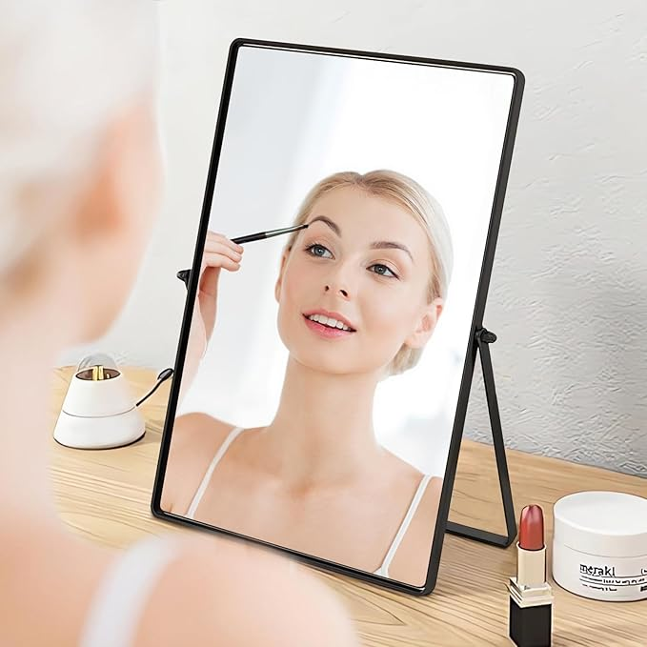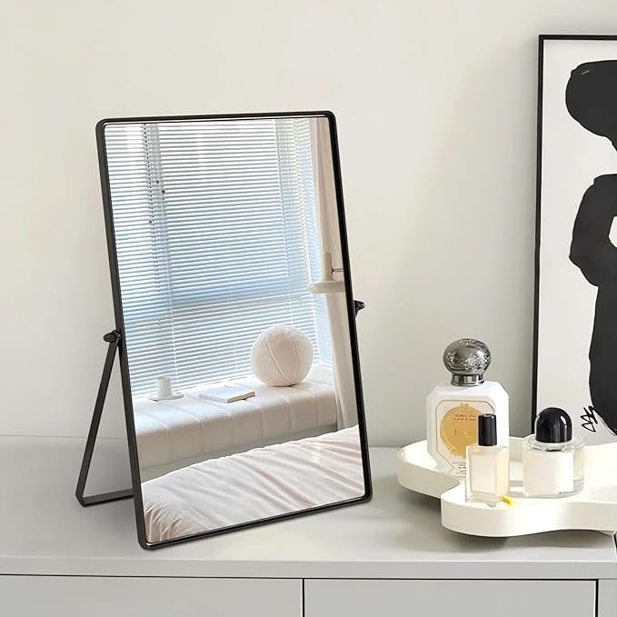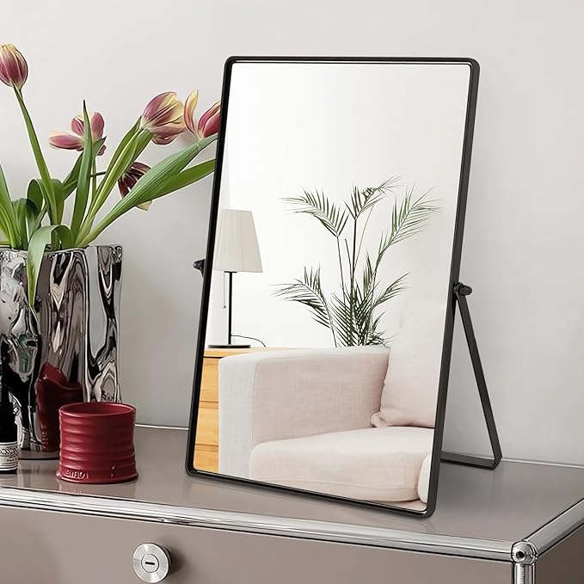

Desktop Makeup Mirror with Black Metal Standing 90° Rotation Vanity Table Mirror Portable Cosmetic Mirror for Dressing Room Bedroom Bathroom Rectangle

**PRODUCT DESCRIPTION:**

|  |  |
| --- | --- |
| Brand | Numjeg |
| Room Type | Bathroom, Bedroom |
| Shape | Rectangular |
| Product Dimensions | 11.81"L x 8.66"W |
| Frame Material | Stainless Steel |
|  |  |

**About this item**

* Material and Size: This Numjeg vanity mirror uses HD smooth mirror, polished and carved carefully, exquisite workmanship. The frame is made of stainless steel metal material with adjustable Angle. It doesn't rust, it doesn't fade. 12*9 inch vertical mirror. Note: This product is a single-sided cosmetic mirror, no magnification effect.
* Simple and Modern Design: Gold, Black and Silver stainless steel frame, exquisite plating process. Simple style, elegant design. Give your bathroom and vanity a beautiful look, adding a stylish and modern touch to any room.
* Portable and Versatile: This mirror can be placed on every tabletop or table, taking up a small space on a bathroom countertop, dresser, dresser, or bedroom dresser. Simple and lightweight design that can be used as a handheld mirror for morning makeup or a shaving mirror. This small mirror is very light. At just 26.5 ounces, it's easy to carry and perfect for travel and camping.
* Ideal family gift: This desk mirror beauty mirror is not only a makeup mirror, but also the perfect classic decoration. It is perfect for everyday use and is also the perfect birthday gift, anniversary gift, Christmas gift, New Year gift, etc for girls, women, makeup lovers or vintage decoration lovers.
* Satisfaction Guarantee; Please feel free to contact us. If you have any questions, please feel free to purchase your vanity mirror. If you find any quality issues, please contact us and we will provide you with satisfactory service within 25 hours.